**ASSIGNMENT – 1**

SOHAM DAS

IT, UG-2

002311001004

1. SELECT * FROM EMP;

1. SELECT DEPTNO, DNAME FROM DEPT;

1. SELECT EMPNO, ENAME, DEPTNO FROM EMP WHERE DEPTNO = 20;

1. SELECT * FROM EMP ORDER BY DEPTNO DESC;

1. SELECT DISTINCT JOB FROM EMP;

1. SELECT ENAME, SAL*12 AS "ANNUAL SALARY", DEPTNO FROM EMP WHERE JOB = 'CLERK' AND DEPTNO = 20;

1. SELECT ENAME, HIREDATE FROM EMP WHERE ENAME LIKE 'S%' OR ENAME LIKE '_C%';

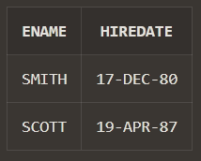

1. SELECT ENAME, HIREDATE, SAL FROM EMP WHERE JOB !='MANAGER';

1. SELECT INITCAP(ENAME) AS TitleCaseName, LENGTH(ENAME) AS NameLength FROM EMP;

1. SELECT ENAME FROM EMP WHERE SAL BETWEEN 4000 AND 6000;

